`



**DONOR REPORT**

**January 2019**





***Finding My Way Grief Support Groups***

**Monday Afternoons**

**Feb. 4—March 11, 2019**

**1:00 pm—3:00 pm**

**Wednesday Evenings**

**March 6—April 17, 2019**

**6:30—8:30 pm**



Sessions are free of charge and take place at Bobby’s Hospice. Call (506) 632-5593 to register. Space is limited.



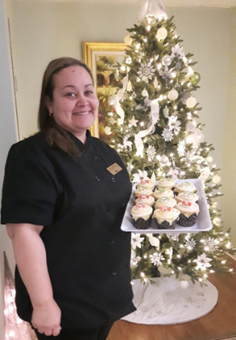

When talking to a patient recently at Bobby’s Hospice, she told me her family wanted her to go home for Christmas dinner, but she was afraid due to her poor health. I could see the hurt she felt, so in that moment I decided to work on Christmas Day so I could serve a special holiday dinner to all of our patients and their families in our large family room.

You see many people think Bobby’s Hospice is a place of sadness where food and celebrations have no place for those who are dying. When actually both are very important to our care and supporting quality of life and helping loved ones spend precious time together.

Food is the one thing a person has control over when often things seem so out of control due to the disease process. My goal as Food Services Manager is to give our patients the joy of taste and memories of food. I often hear that a special treat I make for them tastes exactly like what their mother or grandmother used to make. I treasure those moments.

So this year, I was honored to celebrate Christmas by hosting and serving a special holiday dinner to our patients and their family members at Bobby’s Hospice. This is a memory we will all cherish. Food really is good for the soul!

Tracy Doucet, Hospice Food Services Manager

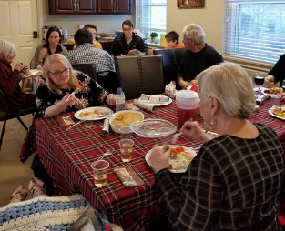



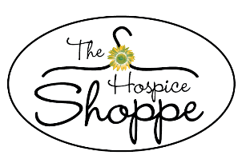******

***Thank you for investing in Hospice!***

***Every year, we must raise over $1M to provide free in-patient palliative care and grief support to over 170 people in our community in need. Your donations make a tremendous difference to people we all know.***

385 Dufferin Row * Saint John, NB E2M 2J9

Tel: (506) 632-5593 Website: [www.hospicesj.ca](http://www.hospicesj.ca)

***“Bobby’s Hospice” and “The Hospice Shoppe” are owned***

***and operated by Hospice Greater Saint John***

***Find Bobby’s Hospice on***

Thank You!